RAJSHAHI UNIVERSITY OF ENGINEERING & TECHNOLOGY



Course no : CSE-2188

Lab Report on

Beginner Level Game

Submitted By: Submitted To:

Group- 04 Md.Faisal Rahman Badal,

Abhirup Sarker 1908017 Lecturer, Department of

Razia Sultana 1908019 Mechatronics Engineering

Sakib Anjum Amio 1908020 Md.Mehedi Hasan, Lecturer

Sadia Tasneem 1908021 Department of

Sarwan Sadique 1908022 Mechatronics Engineering

**Introduction:** Computer programming is the process of performing particular computation by designing, writing codes and building executable programs. Programming language is any set of rules that tells the computer what to do. Python is a very popular programming language which has many applications such as web development, networking, database access and software & game development. The snake game is a very simple but fun game to make on python. The game doesn’t use too much complicated logics or conditions, so it’s perfect project choice for beginners.

**Features:** The key features of our game was:-

1. Player gains point by eating apples
2. Snake gets larger as it eats apples
3. Snake dies after colliding with the wall or itself
4. Opening interface

**Game Screenshots:**

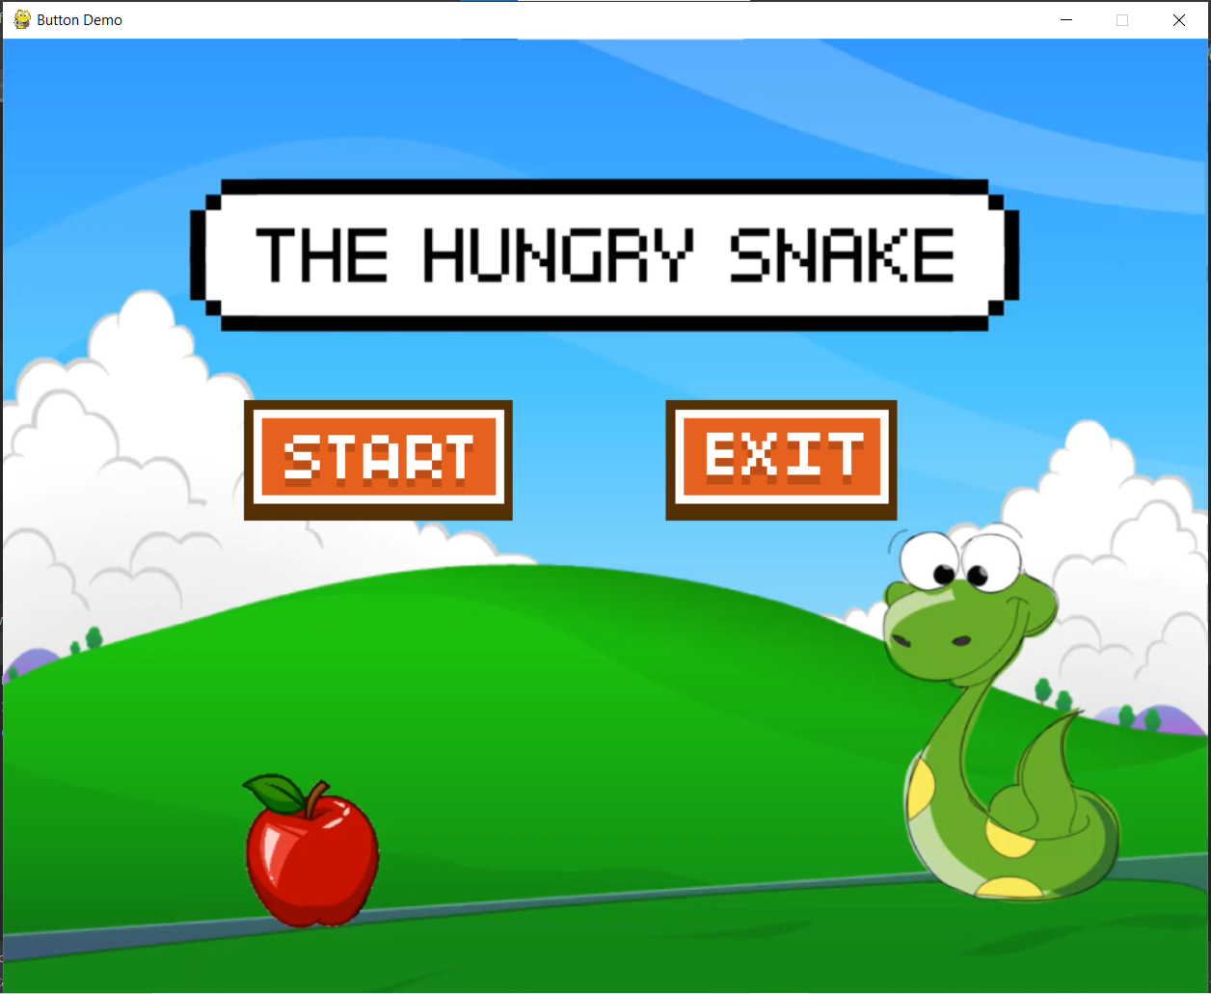

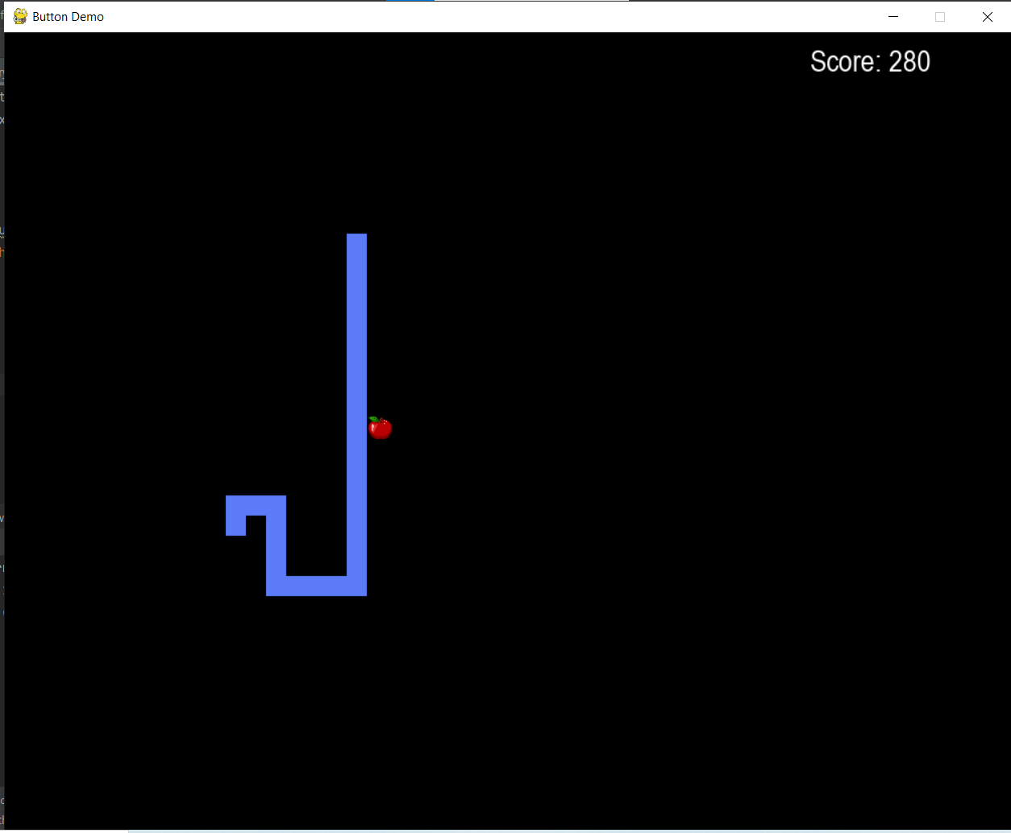

**Code Explanation:** There are classes defined in this program which are Button, Apple, Snake and Game. The classes are used to convert it into object oriented programming and make it easier to initialize different variable and objects as well as fix different errors. For creating the main menu the display method has been used along with the button class which holds the start and exit button of the game. In this class different methods like pygame.mouse.get_pos() & get_pressed() are used to get signal whether the player is starting or leaving the game. If the necessary conditions are true the game starts otherwise the player exits the menu. When the player clicks the start button the event parameter is set to true which leads to the background being updated by pygame.display.update() method and the game screen opens. The game runs until event is set to false, which happens if the player quits or the snake dies and game is over. The length of the snake is increased using the increase length function defined. As the snake eats apples new apple is generated in different place using the random() method. The snake is controlled by keyboard, for this event parameter is set to four different options for moving around. The logic for snake eating apple was, if the coordinates of snake head and the apple are same it counts score. For boundary collision the logic was x<=1000 & y<=800 which shows the snake is going outside the determined area of the screen. mixer.sound is used to add music in the game and image.load used to added the images and backgrounds. The main display was set to update every 0.15 seconds.

**Errors:** The errors we were unable to solve are:-

1. When we added more than one level to the game the snake speed increased so rapidly that it became uncontrollable.
2. We couldn’t add the feature to store highest score.
3. Our executable doesn’t run.
4. There are few minor glitch in the game.

**Discussion:** The project was completed with the help of all the group members. We had faced some difficulties while working on this project such as we were unable to feed the snake apples, the snake was not dying from wall collisions, there was no main menu but we were able to solve all these problems.

**Conclusion:** The aim for this project was to create a beginner level game and we were successful in doing so. We had chosen python as our preferred programming language. We didn’t know much about python when we started the project but now we have gained a good idea of python language and completed our game “The Hungry Snake”.